**American International University Bangladesh (AIUB)**



**Faculty of science & Technology**

**Department of Computer Science**

**LAB TEST**  
CSC 3222 WEB TECHNOLOGIES

Q1: Write the code to read a text file named labTest.txt. The txt fine contains the following content. You need be to careful about the line break and spaces. **3+2 =5**

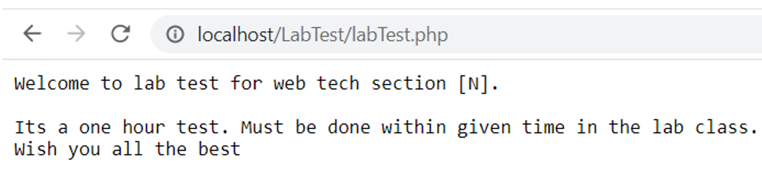

Using write function edit labTest.txt file as follows.

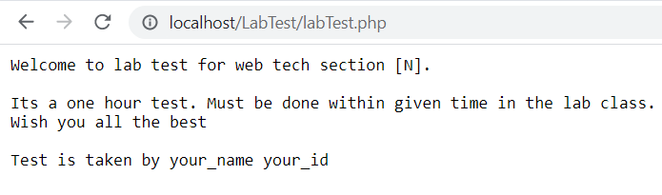

Q2: Define a php class named Student. Student class should have private variables named studentName, studentId, studentDept,studentBloodGroup. Use a function to describestudent(). create 1 student objects. call/invoke describestudent().It should describe yourself as a student. 5

Q3: Write the code to validate the following form to pass the following validation terms. Upon getting error it should show error messages as follows. Else it should show the output in the same page. remember all validation should be using php validation 10

|  |  |
| --- | --- |
| Name: | required |
| Email: | required and should be a valid email |
| Website: | optional but if given must be a url |
| Comment: | optional |
| Gender: | required |

